Dear Member,

You will no doubt already have heard of the increasingly tragic and desperate situation refugees are facing when attempting to enter Europe by crossing the Mediterranean Sea. This perilous route has claimed the lives of thousands of people this year. Thousands more are currently detained across Greece, one of the principle gateways to Europe from the Middle East.

A group of volunteer lawyers and law students are attempting to set up a legal centre in Lesbos to assist in defending the rights of those currently detained there.

Below is further information regarding the project. Their donations page can be found at https://chuffed.org/project/legalcentrelesbos

We urge you to please donate to this worthy cause and share this request to those who you believe would be willing to contribute.

---
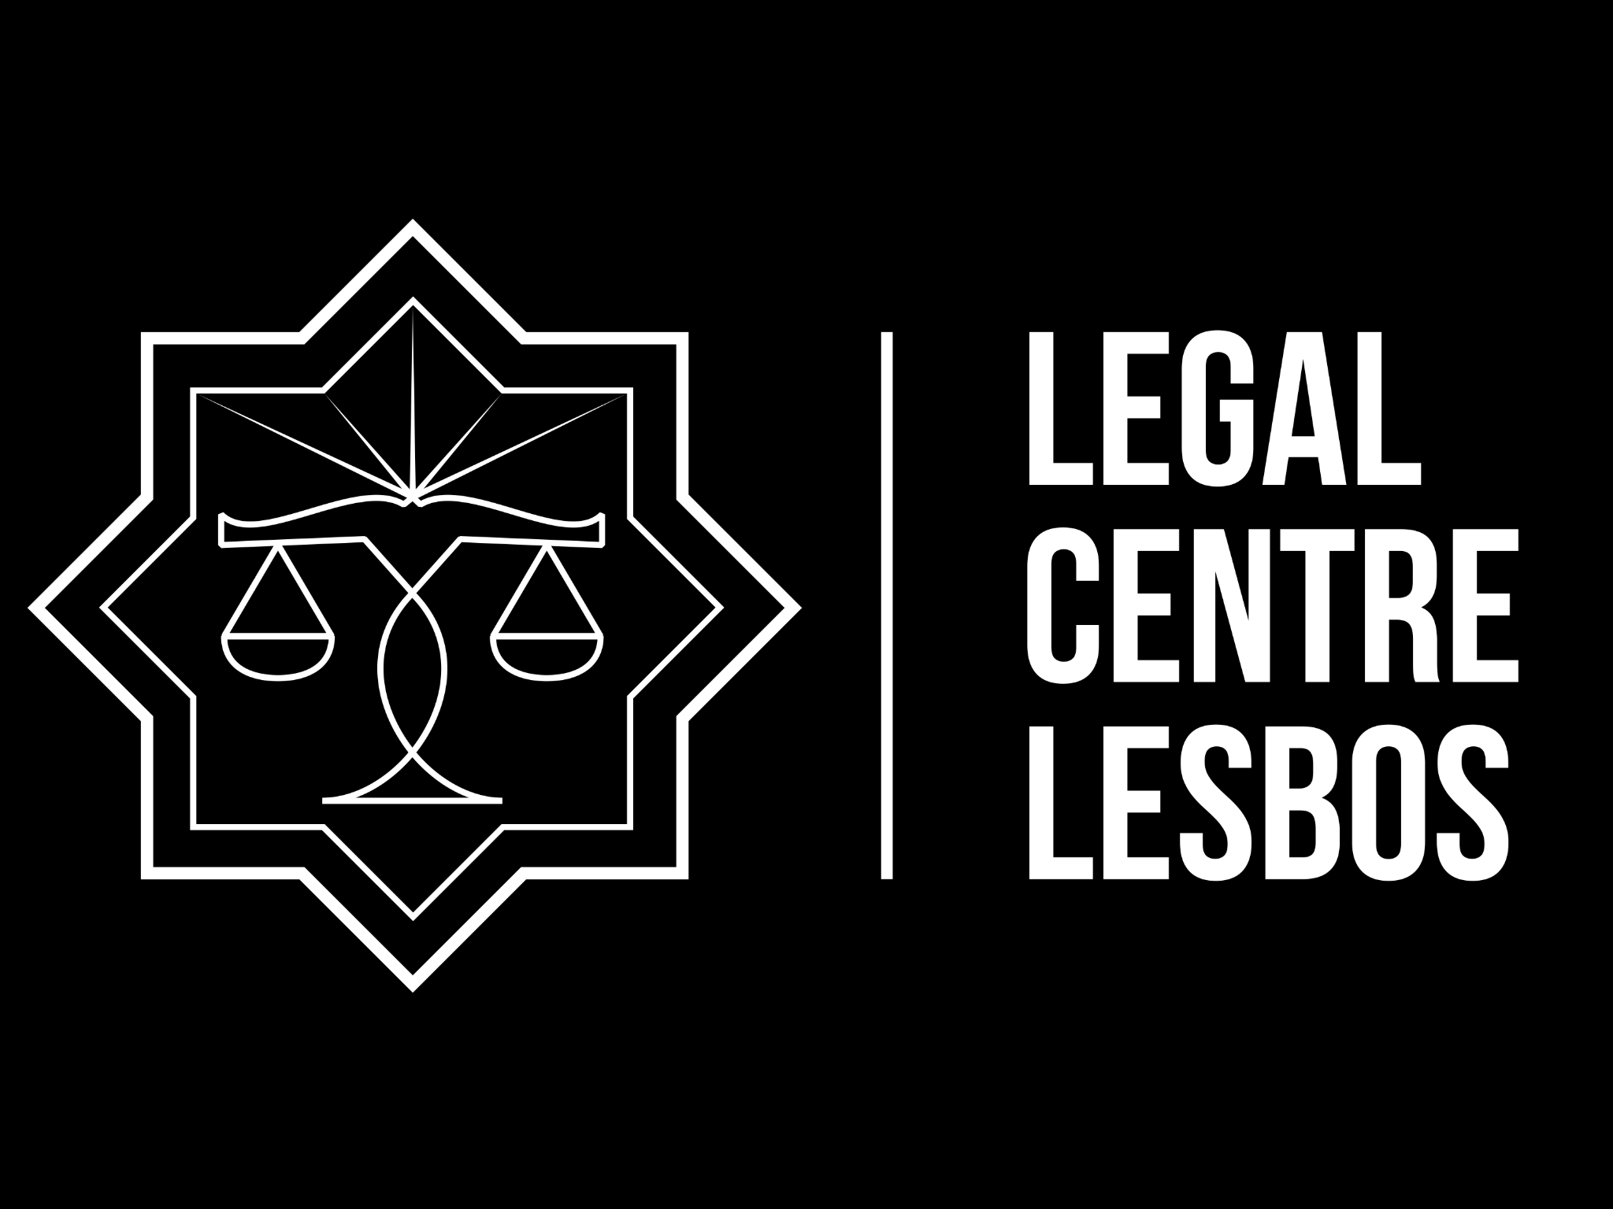
Help us set up a Legal Centre in Lesbos!

The Refugee Crisis
Europe is in the throes of the worst refugee crisis since the Second World War. Millions have made the long, arduous and perilous journey to Europe by land or sea from the Asian and the African continents to flee from the effects of war in those regions.

According to the IOM, 206,400 migrants and refugees have entered Europe by sea between January and the first week of June this year. In the same period, 2,809 have died attempting to make the journey, marking an increase in fatalities of 52% compared to the first 6 months of 2015.

With the causes of this crisis continuing unmitigated, the coming months are expected to see the death toll again rise.

Once those who take the route through Turkey arrive in Lesbos, the majority are detained without access to a lawyer and unaware of their legal rights whilst on the Island. Thousands anxiously wait to see whether they will be transferred back to Turkey, a country controversially considered ‘a safe third country’ despite its arbitrary detention, refoulement and shooting of refugees.

Legal Centre Lesbos
Human rights are being violated in Lesbos. International solidarity is fundamental in trying to help defend the rights of these individuals.

A small group of legally trained international volunteers will be travelling to Lesbos to provide legal information to those based in the camps, assisting Greek lawyers already on the ground. The information that we collect whilst operating within the Legal Centre will serve as a basis for press statements, human rights reports and the formation of refugee centred legal strategies.

We need your help
In order to start the work of the Legal Centre, we need you to help finance this project. Your donations will be used for the following:

• The purchase/construction of a legal centre in one of the camps
• Half the travel costs of the international volunteers coming to Lesbos
• Accommodation and food for the volunteers
• Transport on the island
• Office materials required to provide legal information
• Legal fees for Greek lawyers when applications/representations are required

We are conscious of the need to keep you informed. Once we have the Centre up and running we will aim to keep our donors updated through blog posts and other forms of social media.

We are also conscious of the need for sustainability. We aim to have the centre permanently staffed by local greek human rights lawyers and funded by institutions and organisations that will not threaten the centre’s independence nor its ability to assist and advocate on behalf of the refugees and migrants of Lesbos.

Our Supporters
The Legal Centre has been endorsed by the following international and national associations:

The International Association of Democratic Lawyers
European Lawyers for Democracy and Human Rights
Asociación Americana de Juristas
Alternative Intervention of Athens Lawyers (Greece)
Hellenic Union of Progressive Lawyers (Greece)
Associazione Dei Giuristi Democratici (Italy)
Indian Association of Lawyers (India)
Haldane Society of Socialist Lawyers (UK)
Juristes Democrates de Suisse (Switzerland)
German Association of Democratic Lawyers (Germany)

Help us to speak truth to power
Europe is at a cross roads. Grass roots support and solidarity is required at all levels. Help us provide a voice for the refugees and migrants of Lesbos. Help us establish a legal centre.

The coordinator of this project, Carlos Orjuela, can be contacted on legalcentrelesbos@gmail.com

